# **Install Istio with Kubernetes cluster**

1. Make sure you have running K8 cluster
2. Make sure you have been able to make connection with Kubectl
3. Install Istoctl on the client system to run istoctl command

Run these commands in git bash

# Specify the Istio version that will be leveraged throughout these instructions

ISTIO_VERSION=1.0.4

curl -sL "https://github.com/istio/istio/releases/download/1.0.4/istio-$ISTIO_VERSION-linux.tar.gz" | tar xz

## Installing Helm to deploy Istio components on K8 cluster

1. Install helm cli in your local system use helm commands

3.1) I use a windows 7 system – so in order to get the helm cli, you will need to first install chocholatey on your system

- @"%SystemRoot%\System32\WindowsPowerShell\v1.0\powershell.exe" -NoProfile -InputFormat None -ExecutionPolicy Bypass -Command "iex ((New-Object System.Net.WebClient).DownloadString('https://chocolatey.org/install.ps1'))" && SET "PATH=%PATH%;%ALLUSERSPROFILE%\chocolatey\bin"

3.2) Install Curl using chocolatey

- choco install curl

3.3) Install the kubernetes helm

- choco install kubernetes-helm

3.4) Installing through script (the below commands will only run in gitbash)

- curl https://raw.githubusercontent.com/helm/helm/master/scripts/get > get_helm.sh

- chmod 700 get_helm.sh

- ./get_helm.sh

1. Helm cli is now installed on your system.
2. You need to deploy Helm to K8 cluster and use the helm charts to deploy multiple services (Istio one among them on your cluster)
3. You need to use a service account “tiller” and provide it access to deploy artifacts in namespaces on k8 cluster using helm.
4. In order to create a service account – use the below configurations

kind: ClusterRoleBinding

apiVersion: rbac.authorization.k8s.io/v1beta1

metadata:

name: tiller-clusterrolebinding

subjects:

- kind: ServiceAccount

name: tiller

namespace: kube-system

roleRef:

kind: ClusterRole

name: cluster-admin

apiGroup: ""

1. Put this in a file and name it as helm-rbac.yml (you can name it as you wish)
2. The above scripts is creating a service account called tiller under the namespace kube-system (kubernetes pre created namespace). A role is created and the role is binded with subjects. The role is cluster-admin
3. Now , create the tiller service account in kube-system namespace

* kubectl create serviceaccount --namespace kube-system tiller

1. Create a cluster role binding and apply it to the tiller service account

* kubectl create clusterrolebinding tiller-cluster-rule --clusterrole=cluster-admin --serviceaccount=kube-system:tiller

1. Apply the helm-rbac.yml using kubectl apply -f helm-rbac.yml
2. Then initialize helm on your cluster for the tiller service account using - helm init --service-account tiller –upgrade. Make sure you are in the folder where istio win zip was extracted.

**The tiller service account is a server side component of helm – which will help helm in installing artifacts to different namespaces within your cluster, hence permission is required for the service account and hence cluster role was created and was binded to the service account.**

1. Check if tiller deploy service and deployment and pods are created under kube-system namespace.
2. If yes then follow step 17
3. Remember the Istioctl that was downloaded in the 3rd step – go to that folder and then

C:\Users\IBM_ADMIN\git\IbmService\istio-1.0.4>helm install install/kubernetes/helm/istio --name istio --namespace istio-system --set global.controlPlaneSecurityEnabled=true --set grafana.enabled=true

--set tracing.enabled=true --set kiali.enabled=true

1. The above command should install Istio on your system under istio-system namespace – need to make sure istio-system namespace is pre created (kubectl create namespace istio-system).
2. Some times you find problems during installation and need to reinstall

* 1) kubectl delete deployment tiller-deploy --namespace kube-system
* 2) kubectl delete service tiller-deploy --namespace kube-system
* 3) kubectl delete serviceaccount tiller --namespace kube-system
* 4) kubectl delete clusterrolebinding tiller-cluster-rule
* 5) kubectl delete -f install/kubernetes/helm/istio/templates/crds.yaml -n istio-system

1. Some times you will need to reinstall the entire istio – make sure that you are under the folder where istio is downloaded in your client system, start cmd prompt, and run helm del --purge istio

Then run

helm install install/kubernetes/helm/istio --name istio --namespace istio-system --set global.controlPlaneSecurityEnabled=true --set grafana.enabled=true -- set tracing.enabled=true --set kiali.enabled=true

1. Try the installation again from step 11
2. Verify the istio installation

kubectl get svc --namespace istio-system --output wide

output

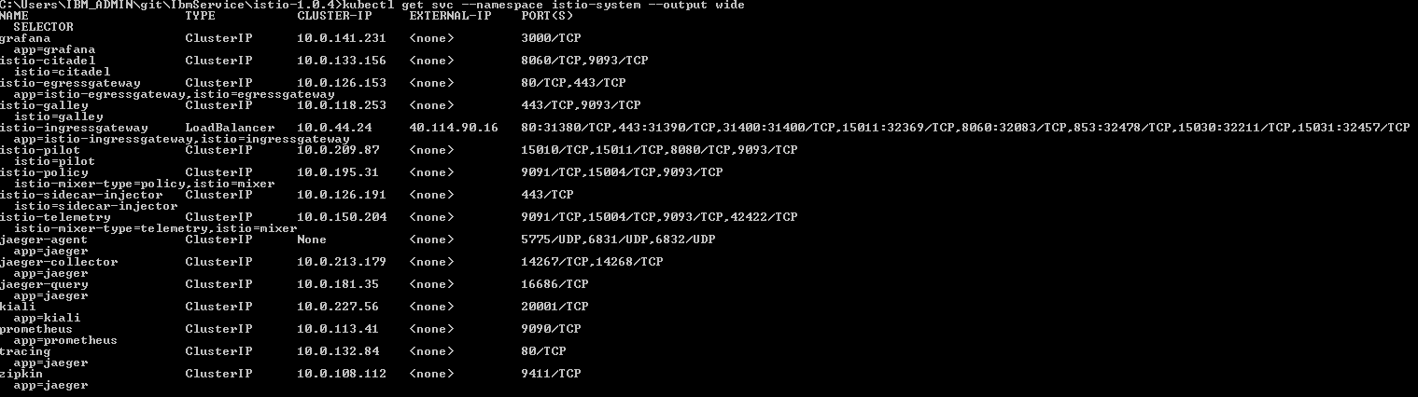

* *istio-*\* services
* *jaeger-, *tracing*, and *zipkin* add-on tracing services
* *prometheus* add-on metrics service
* *grafana* add-on analytics and monitoring dashboard service
* *kiali* add-on service mesh dashboard service

1. verify - kubectl port-forward grafana-7b6d98d887-r5jgj --namespace istio-system 3000:3000